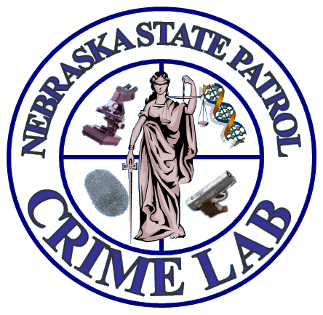
Lai

Lab Sections & Analytical Capabilities
Laboratory Director: Jason Linder
Hours of Operation: Monday – Friday, 8am – 4:30pm
Evidence Receipt Hours: Monday – Friday, 9am – 4pm
Main Phone: 402 – 471 – 8950
Fax Number: 402 – 471 – 8954
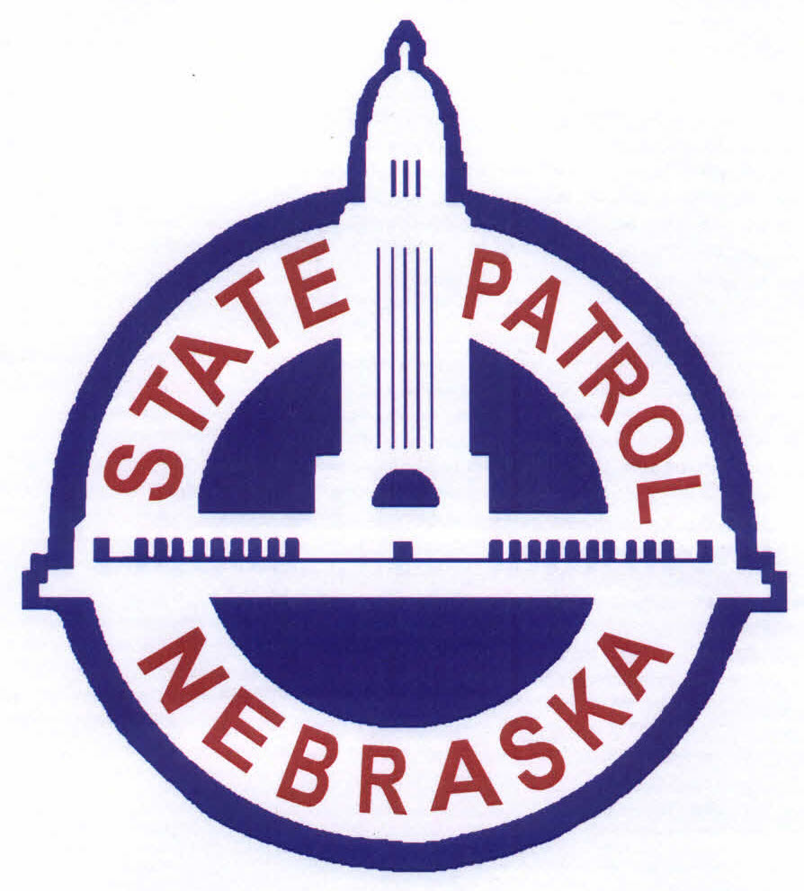

The Nebraska State Patrol Crime Laboratory is a full service forensic laboratory that is internationally accredited by the ANSI National Accreditation Board (ANAB). Our legislative mandate under 81-2010 is to “…perform services necessary for the recognition and proper preservation, identification, and scientific analysis of evidence materials pertaining to the investigation of crimes.” We are entirely tax and grant funded and available (free of charge) to all law enforcement agencies in the state of Nebraska.

https://statepatrol.nebraska.gov/divisions/investigative-services/crime-laboratory

QUALITY ASSURANCE AND CASE MANAGEMENT CAPABILITIES

Quality Assurance Section

The Quality Assurance Section manages all aspects of the laboratory’s Quality Assurance System to ensure analyses; reports and testimony provided for law enforcement agencies are accurate, impartial and relevant.

Areas of the QA System include:

- Document Control – Ensures only current procedures are used and properly distributed.
- Case File Review – Administrative and Technical
- Proficiency Testing – All analysts are regularly proficiency tested in their areas of expertise.
- Court Testimony Monitoring – Regular review of testimony provided by analysts to ensure testimony provided is technically accurate, clearly understood by the court/ jurors, professional.
- Audits/ Corrective Action – Regular review of compliance with established laboratory procedures. Implementation of corrective actions for non-compliances.

The Quality Assurance Section ensures the laboratory maintains its international accreditation through the ANAB (ANSI National Accreditation Board).

Case Management Section

- Receives and releases evidence submitted by law enforcement agencies throughout the state.
- Facilitates evidence transfers throughout the laboratory.
- Manages case records for all analyses performed at the laboratory.
- Provides administrative support for the laboratory.
  - Route incoming phone calls
  - Accept deliveries; greet and assist visitors
  - Provide attorneys with document requests
Sealing requirements for evidence submitted to the laboratory:

- Tape sealed with initials across both sides of the tape
- Heat sealed (plastic bags) with initials across the heat seal
- Pre-manufactured self sealing evidence bags with initials on the bag
Certified mail:

- Submittal on the outside of sealed package
- Freeze urine before mailing
- Submit ONE case per certified mail tag

BIOLOGY UNIT CAPABILITIES

Biology Forensic Casework Section is responsible for examining any items of evidence for any potential biological evidence and for the possible determination of the origin of the biological material.

Biological Screening Capabilities:
- Blood
- Semen
- Saliva (Presumptive Only)
- Urine (Presumptive Only)
- Biological Evidence Transfer
- Limited hair examinations
  - Is it a hair?
  - Human vs. Non-Human (Limited)?
  - Acceptable for nuclear DNA analysis

Human DNA Typing Capabilities:
- The analysis of 24 STR (Short Tandem Repeats) loci and interpretation using probabilistic genotyping
  - Includes the core CODIS loci
- Reference samples should be obtained from all individuals involved for comparison to the evidence DNA profiles
- Perform examination of “no suspect” cases and enter the appropriate DNA profiles into CODIS to search for possible DNA matches
- Trace (Touch) DNA may be possible
- Criminal paternity testing is limited
- Limited capabilities for DNA analysis from bone
CODIS Database (Combined DNA Index System) Section – DNA database designed by the FBI to compare DNA profiles from case evidence to other cases and convicted offender DNA profiles
- NDIS: The National DNA Index System is the DNA database maintained by the FBI.
- SDIS: The State DNA Index System is the DNA database maintained by the individual states. The Nebraska State Patrol Crime Lab is the custodial agency for the Nebraska SDIS Database.
- LDIS: The Local DNA Index System is the DNA database maintained by individual government law enforcement agencies. No LDIS databases exist in Nebraska at this time.

The CODIS Database consists of the following components:
  - Convicted Offenders
    - Samples collected from persons convicted of qualifying crimes maintained at the NDIS level. The qualifying crimes are determined by individual state statutes. (Nebraska State Statutes, Article 41, section 29-4103 (6)
  - Forensic Unknowns
    - DNA profiles from evidentiary samples from solved or unsolved cases which are searched against other Forensic Unknowns and against the Convicted Offender Database. The Forensic Unknown profile must meet strict criteria for upload to NDIS. Samples not meeting the strict criteria may be uploaded and searched at the SDIS or LDIS level as allowed under state statutes or rules and regulations.
  - Missing Persons & Unidentified Remains
    - Known DNA profiles from missing persons or DNA profiles from unidentified remains that are searched against each other and the relatives of missing persons.
  - Relatives of Missing Persons
    - Known DNA profiles from the relatives of missing persons that can be searched against any unidentified remains.

PHYSICAL SCIENCES UNIT CAPABILITIES

Latent Print Section Capabilities

The Latent Print Section is responsible for examining items collected at the scene of crime, which may contain friction ridge detail needed for identification and/or elimination purposes.

Non -porous items submitted for latent examination are processed first by superglue fuming, and then by powders, and/or fluorescent dyes.

Non-porous, glossy (non-textured) items can also be examined with Reflective Ultra Violet Imaging System (RUVIS) or the Full Spectrum Imaging System (FSIS) for the presence of value friction ridge detail. RUVIS and FSIS both operate under short UV light and do not require previous chemical processing (superglue fumes, powders, dyes). The use of RUVIS or FSIS is extremely beneficial on high-value items (antiques, collectibles, electronics, etc.) due to their non-destructive nature to the physical appearance of the evidence items. RUVIS and FSIS are HIGHLY destructive to DNA, however. With this in mind, the collection of DNA samples should ALWAYS be conducted PRIOR to RUVIS or FSIS examination.

Porous items are processed by using Ninhydrin, DFO, Physical Developer, etc.

Any latent impression found to contain sufficient quality and quantity of friction ridge detail is captured using digital photography. Digital images are further processed in Adobe Photoshop for the best possible ridge detail, and the final product is then imported into the Nebraska AFIS. Latent prints may also be searched through NGI upon request.

Items that can be submitted for latent processing include:

- Porous items (paper, cardboard, raw wood, etc.);
- Non-porous items (glass, plastic, metal, etc.);
- Sticky tape (duct tape, electric tape, scotch tape, packing tape, etc. Both sides can be processed);
- Bullet casings(except 22cal);
- Impressions in blood, paint, or other substances;
- Digital files containing photographs of latent impressions (TIF format or RAW format, with metric scale included in the frame; at least 1000 pixels-per-inch (ppi) resolution images recommended)

Fingerprint Databases:

- AFIS – Automated Fingerprint Identification System is a Nebraska state fingerprint system maintained by the Nebraska State Patrol (NSP). The system contains 657,150 person ID’s; 1,213,603 Incidents; and 14,925 unidentified latent impressions (information as of March 14, 2017).
- NGI – Next Generation Identification is a replacement of IAFIS (Integrated Automated Fingerprint Identification System). NGI is maintained by the Federal Bureau of Investigation (FBI), Criminal Justice Information Services (CJIS) Division and it contains the largest biometric database in the world, containing the fingerprints, palm prints and corresponding criminal history information for more than 138 million subjects in the Criminal Master File. These records are submitted voluntarily by state, local, tribal, federal and international agencies. The NGI system offers state-of-the-art biometric identification services and compiles core capabilities that serve as the platform for multimodal functionality. Besides fingerprint and palm print impressions, NGI also contains the rapid search service called Repository for Individuals of Special Concern (RISC); the Interstate Photo System for Facial Recognition (IPS); Rap Back Services, and Iris Recognition (IR).
Both systems provide automated fingerprint and palm print search capabilities, latent searching capability, electronic image storage, and electronic exchange of fingerprints and responses 24 hours a day, 365 days a year.

Firearm / Tool Mark Section

- Bullet Analysis:
  - Determination of caliber and/or class characteristics. (NG Cases*)
  - General Rifling Characteristic (GRC) analysis to determine possible makes/models of source firearms. (NG Cases*)
  - Comparison to other evidence bullets / determine number of firearms represented. (NG Cases*)
  - Comparison to test fired bullets from submitted firearm.
  - Potential identification or exclusion from suspect firearm.

- Cartridge Case/Shotshell Analysis:
  - Examination of firing pin/breechface/ejector mark style to determine possible makes/models of source firearms. (NG Cases*)
  - Comparison to other evidence cartridge cases / shotshells to determine # of firearms represented. (NG Cases*)
  - Comparison to test fired cartridges/shotshells from submitted firearm.
  - Interpretation/identification of headstamp & caliber (e.g. foreign/military headstamps). (NG Cases*)
  - Potential identification or exclusion from suspect firearm.

- Firearm Function & Identification:
  - Basic operation & troubleshooting (broken parts, obstructions, testing of reported scenarios, trigger & safeties operation, etc.).
  - Silencer/Suppressor construction & component analysis
  - Determine modifications (full auto conversions, trigger/sear mods, etc.).
  - Critical measurements (barrel length, overall length, etc. as per State/Federal gun laws).
  - Test fires for basic function & full auto operation.
  - Identify firearm type/make/model/importer through markings, measurements, etc. (useful for ATF traces & stolen gun checks).

- Serial Number Recovery (useful for ATF traces, stolen gun queries, comparison to stolen property lists):
  - Magnetic Particle Inspection.
  - Chemical etching & enhancement.
  - Locate hidden serial numbers or cross-referenced part numbers.

- Gunshot Residue/Muzzle to Target Range Estimation:
  - Visual & stereoscopic pattern/powder analysis on clothing/other target.
  - Infrared visualization/capture of gunshot residue patterns.
  - Chemical enhancement of residue patterns on clothing/other target.
  - Chemical enhancement for presence of lead or copper (bullet wipe) around perforation on clothing/other target.
  - Shot pattern analysis on clothing/other target.

- Toolmark Analysis:
  - Tool to impression comparisons (padlocks, pried items, cut wire/fence, doorknobs forced with gripping tool, etc.), potentially to identify or exclude suspect tool.
  - Produce toolmarks with suspect tools for comparison to evidence toolmarks.
  - Fracture match of fragmented items (tools, knife blades, keys, vehicle parts, lock pieces, etc.)
  - Knife (or cutting tool) comparisons to cut marks in tires, cables, etc.

- Footwear Analysis:
  - Determination of physical size and pattern correspondence.
  - Comparison between photos, casts, lifts, shoes, etc. for potential identification or exclusion of suspect shoe(s).
  - Produce test prints/impressions for comparison to evidence impressions.
  - Identify brand/style of shoe for questioned impressions.

- Tire & Tread Analysis:
  - Determination of physical size and pattern correspondence.
  - Comparison between photos, casts, lifts, tires, etc. for potential identification or exclusion of suspect tire(s).
  - Produce test prints/impressions for comparison to evidence impressions.
  - Identify brand/style of tire for questioned impressions.

* NG Cases: Exams that can be performed in “no gun” cases in order to develop investigative leads or provide additional details of key evidence items.

CHEMISTRY UNIT CAPABILITIES

Drug Section

- Analysis of samples for controlled substance identification which includes, but is not limited to:
  - Powders for the presence of most controlled substances
  - Liquids for the presence of most controlled substances
  - Plant material to identify, marijuana, THC, KHAT, and K2 compounds
    - 1% THC determination for PLANT MATERIAL samples charged at a misdemeanor or higher level
- Purity of methamphetamine samples for federal prosecution

Toxicology Section

- Analysis of urine samples for the presence of drugs in DUI - D cases.
- No alcohol analysis of any kind

